Governor Overview

Home Page
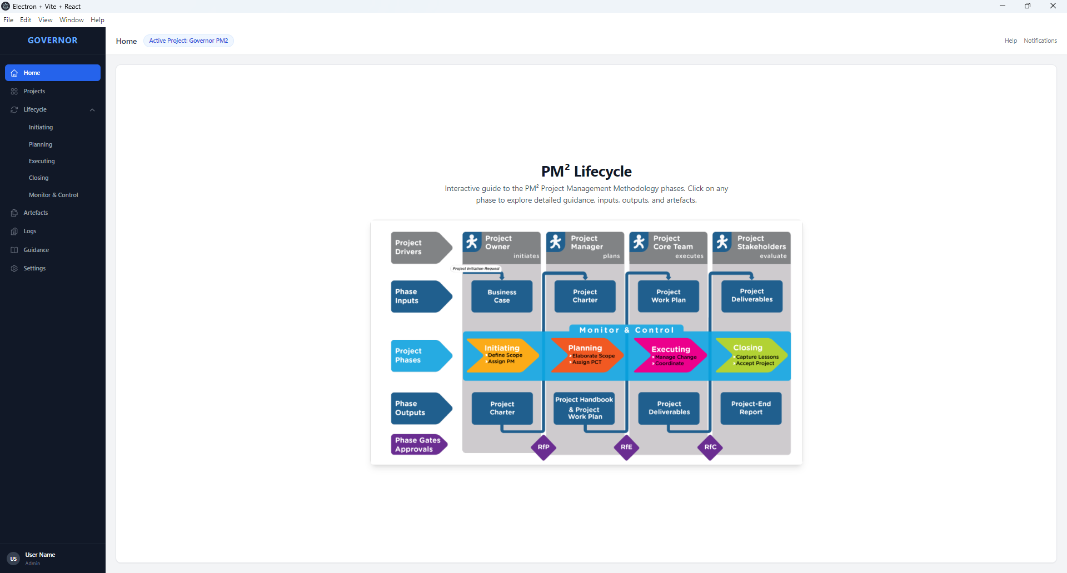
The blue row in the middle has clickable hotspots that navigate the user to the lifecycle sections.
Leaving this for now. But I think it might be one to review and improve/repurpose.

Projects Page
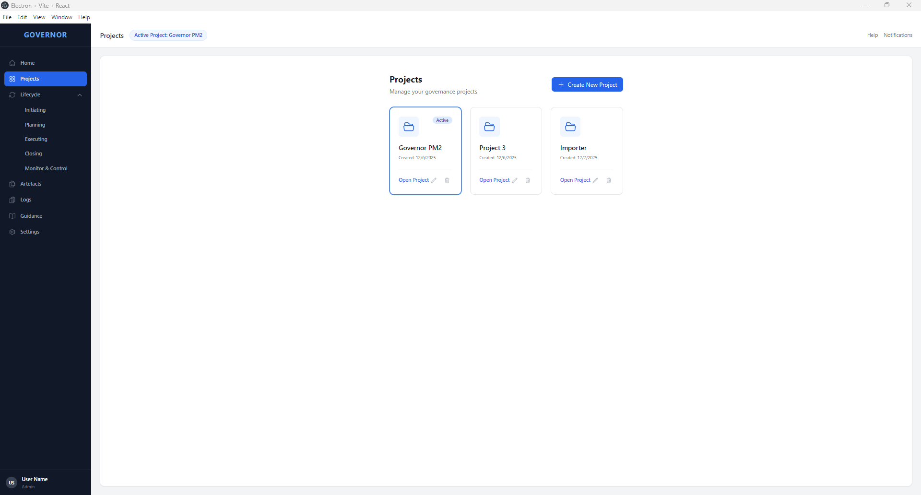
You can create new projects on this page, and switch to a different project to make it active.
This seems to work fine.

Initiating Phase Page
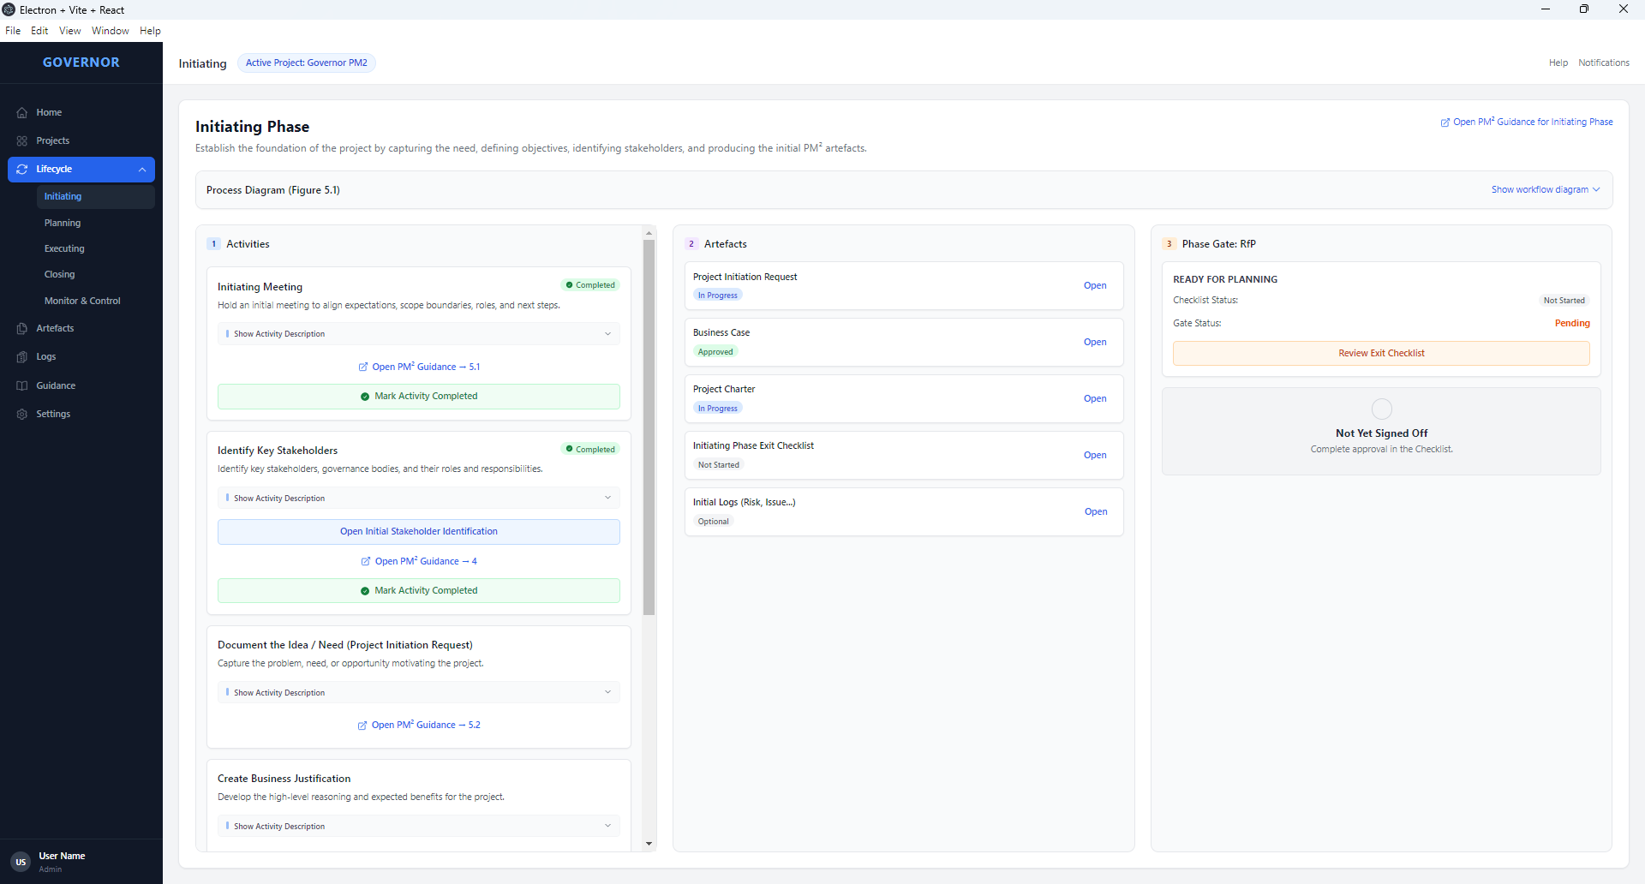
This page is the “cockpit” for the initiating phase. It follows the process diagram from the methodology guide.
The Activities column on the left side lists the initiating phase activities in order.
The middle column, “Artefacts” is for the initiating phase artefacts.
The column on the right is dedicated to the stage gate “Ready for Planning”.
From this page (and every main page) you can open the relevant guidance from the official pm2 guide (see next page)

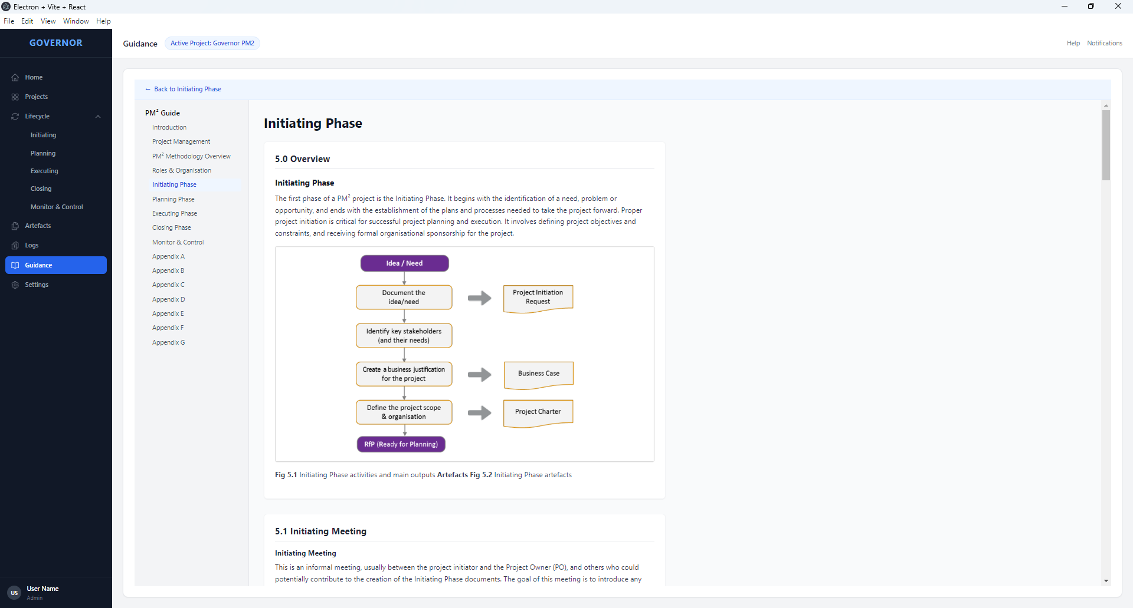
This guidance – a faithful copy of the pm2 project methodology guide – can also be accessed from the menu on the left.
On any lifecycle page, you can also show the process diagram from the guide (see next page)

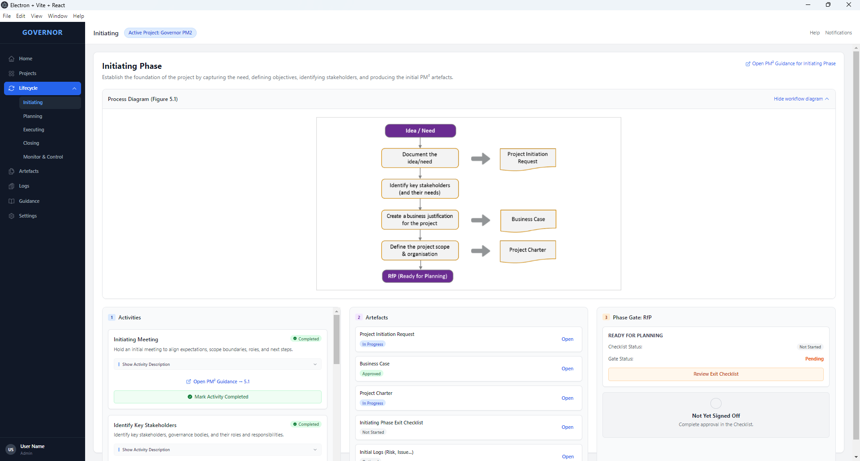
Currently, we only have the Initiating phase partially built and have not started on the other phase pages. But the intention is that all “Phase” pages will follow this standard with the identical user interface elements and user experience.

Initial Stakeholder Identification
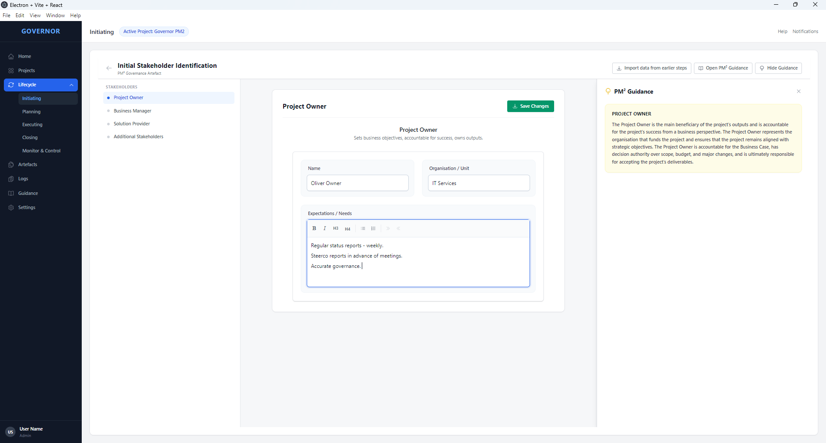
The Initial Stakeholder Identification artefact supports the structured identification and documentation of key stakeholders during the PM² Initiating Phase. It captures the core governance roles defined by the methodology, including Project Owner, Business Manager, and Solution Provider, alongside any Additional Stakeholders who may influence or be affected by the project.
The artefact is presented as a document-style editor rather than a wizard, allowing non-linear navigation between stakeholder sections via a persistent left-hand index. Each section can be edited independently and saved explicitly, supporting iterative refinement as understanding evolves.
Additional Stakeholders are managed using a modal-based add and edit pattern, providing a focused data-entry experience consistent with other repeatable entities in Governor, such as Risks in the Project Charter. Context-sensitive PM² guidance is available for each role and is aligned with the official methodology definitions.
This artefact is intended as an internal governance aid rather than a standalone deliverable and is therefore focused on accurate data capture rather than export or publication.

